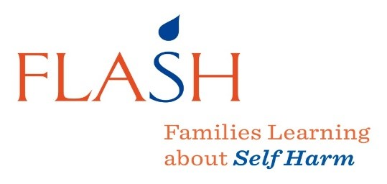

FLASH GROUP DATES
Group facilitators’ contact number:

SESSION | DATE | TOPIC
1 |  | INTRODUCTION, OVERVIEW OF THE PROGRAMME, BEFORE EVALUATION
2 |  | TEEN DEVELOPMENT
3 |  | SELF-HARM – REALITY AND FEARS
4 |  | LISTENING SKILLS
5 |  | PRAISE AND BUILDING SELF-ESTEEM
6 |  | WALKING ON EGGSHELLS
7 |  | CONSEQUENCES
8 |  | MANAGING DIFFICULT TIMES
9 |  | THE OTHERS- LOOKING AFTER THE FAMILY
10 |  | PUTTING IT ALL TOGETHER, EVALUATION AND ENDING

