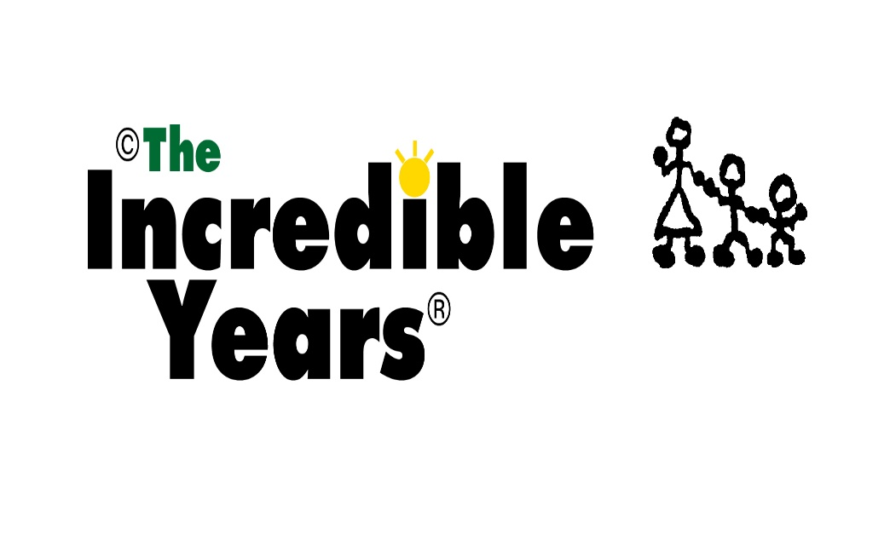Best Hopes
- Name: Improved relationship with children. example
- Name: Learn strategies.
- Name: Shared experience.
- Name: Reduce shouting and stress, better understanding.
- Name: As above, reduce guilt, parenting be more on the same page.
- Name: Learn more
- Name: Less stress, more balanced family dynamic.
- Name: All of the above, more open relationship, enjoy parenting.
- Name: All of the above, calmer household.
- Name :More understanding of emotions.

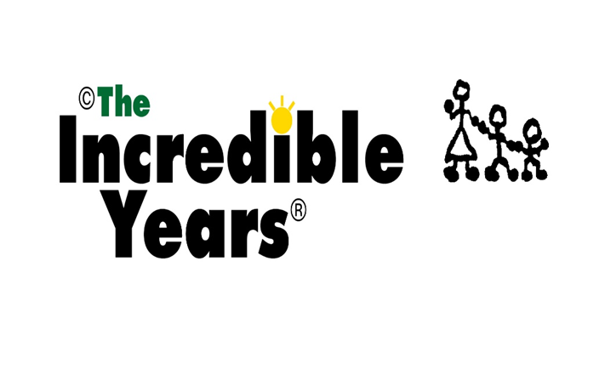Our Group Manners
- Have fun
- Be open
- No judging
- ‘Phones on, take calls outside
- Right to pass
- If we see each other outside, say ‘Hi’
- No gossiping.
- Spelling doesn’t matter.
- We worry, please let us know if you need to miss a week or are going to be late.
- We have a professional duty to safeguard. This means if there is a risk of harm to anyone, we must take action

