“The kids guide to staying awesome and in control: simple stuff to help children regulate their emotions and senses” by Lauren Brukner

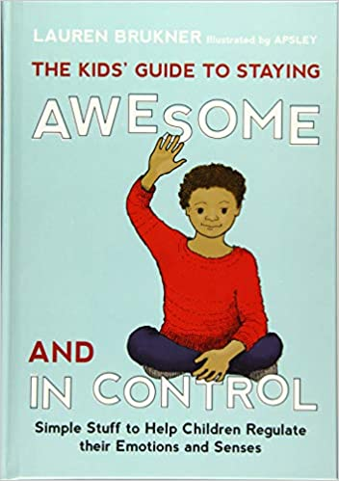

From breathing exercises, pressure holds, and finger pulls, to fidgets, noise-reducing headphones and gum, the book is brimming with fun stuff to help kids feel cool, calm and collected. They will learn how to label difficult feelings, choose the perfect strategies and tools to tackle them, and use these correctly whether at home or at school. The strategies and tools are accompanied by cartoon-style illustrations, and the author includes useful tips for parents and teachers as well as handy visual charts and checklists to track learning and progress.
Armed with this book, kids will be well on their way to managing difficult emotions and feeling just right in whatever situation life throws at them! Suitable for children with emotional and sensory processing difficulties aged approximately 7 to 14 years.

