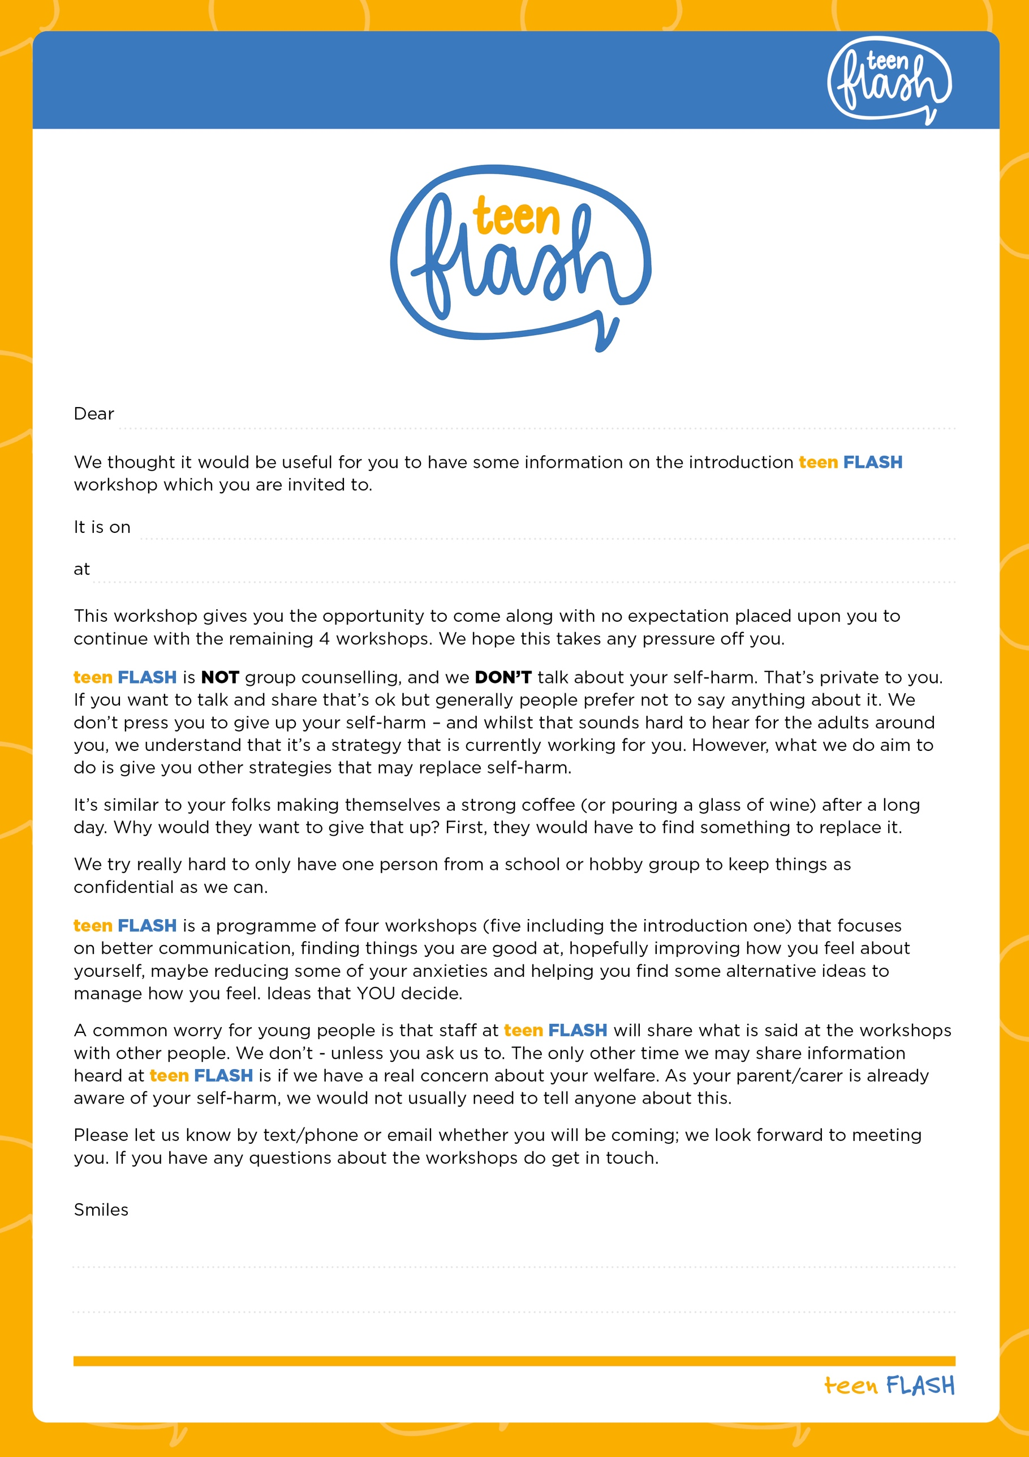
signature
contact number
insert time and venue
insert date
young person’s name

